Level 1 -> Level 2

The goal of this level is to open the – (dash) file and get the password of next level.

So now, firstly we will check the files and folders of the current directory in which we are by using **ls** command. Simple **ls** command is used to list out all the files and folder of the directory in which the user is present.

When we run **ls** command it lists the name of files present. We found the required file i.e. **-**.

We can’t read the content of the **– (dash)** file by simply using **cat** command. So to use the dash file we simply need to use **./** before the file name i.e. **–** (dash). The file contains the password for level 2.

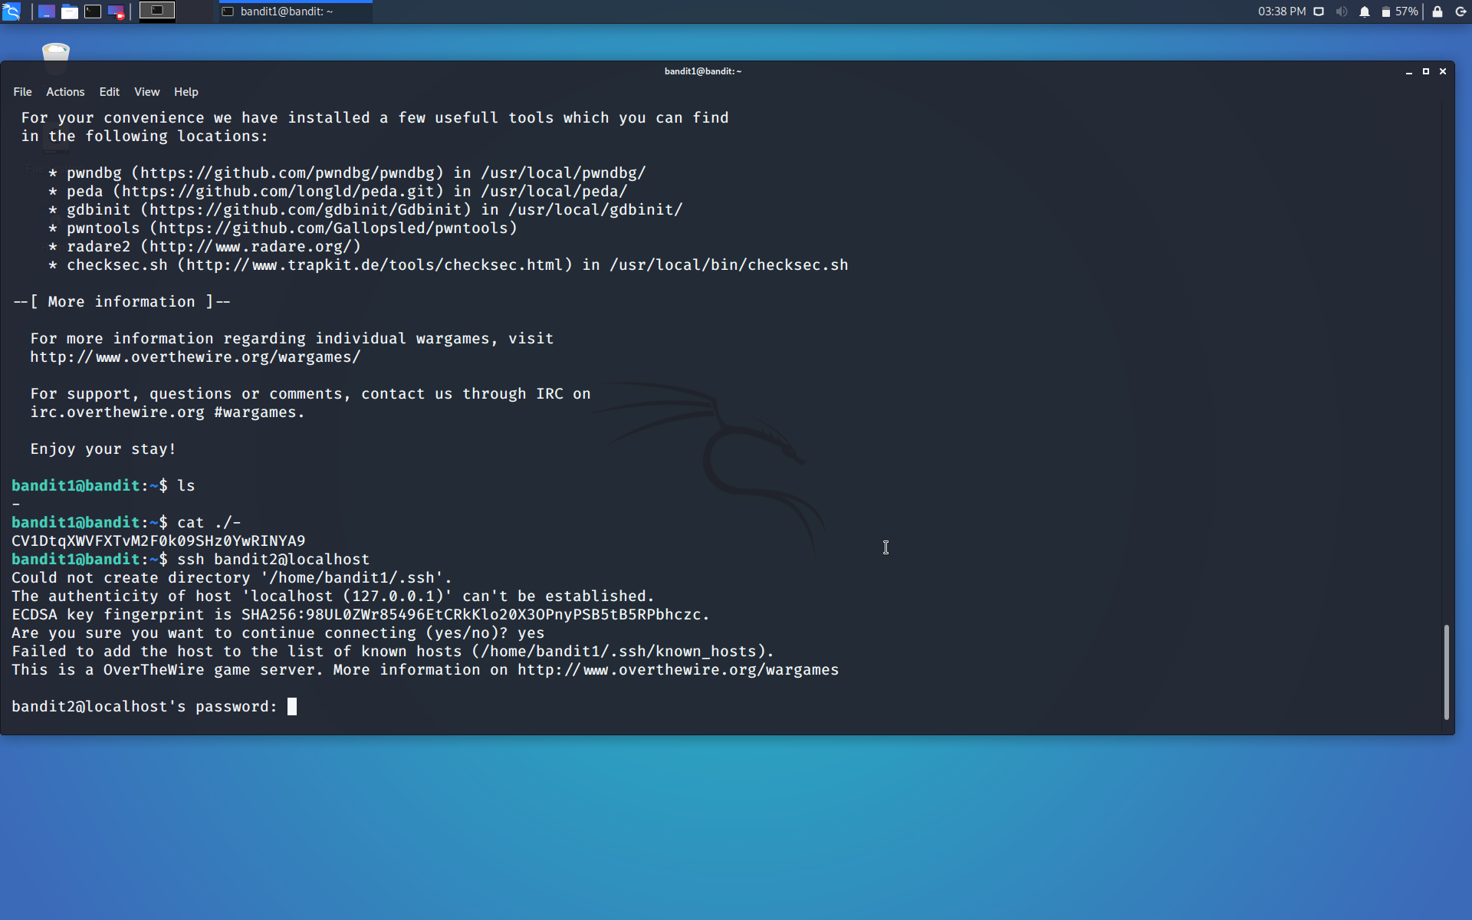

Use the command **ssh bandit2@localhost** to connect to the level 2.

Enter the password and hit enter.

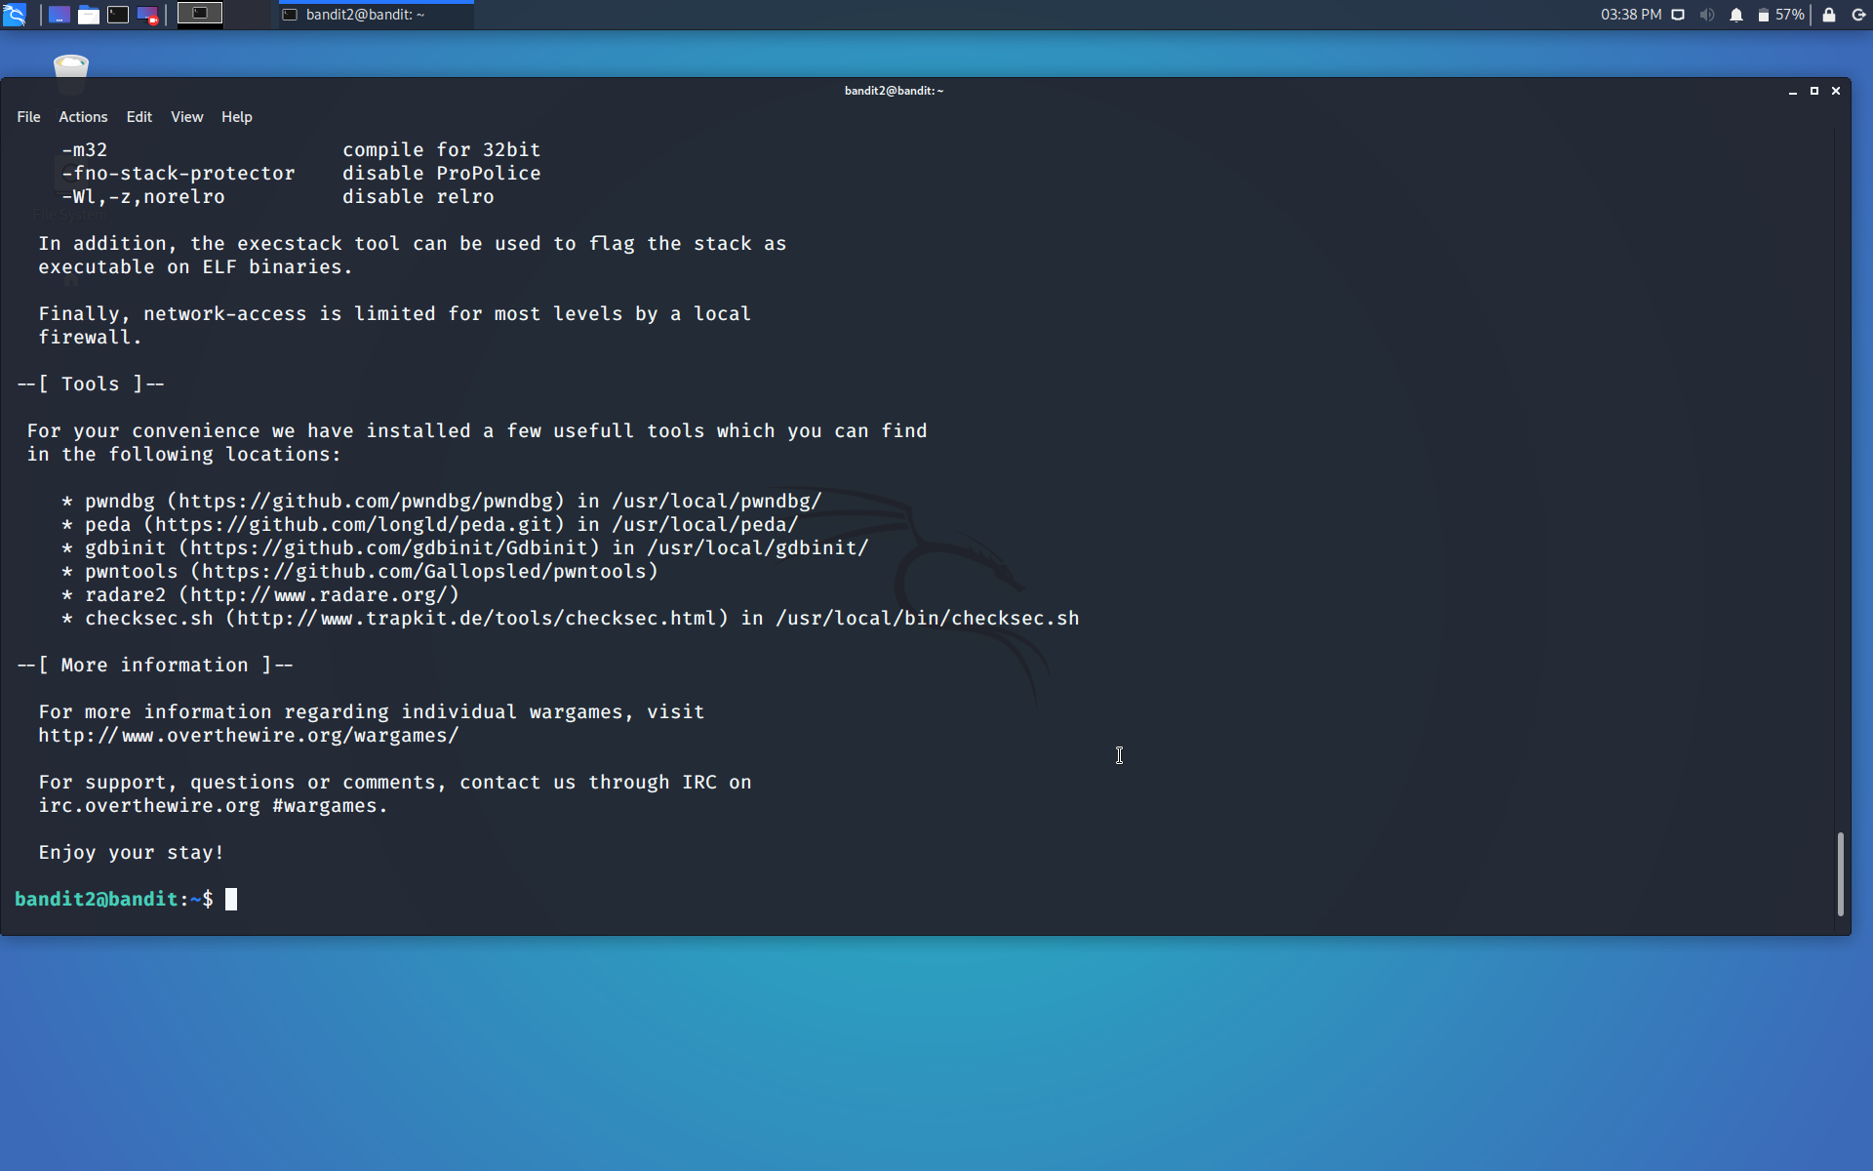

Successfully passed level 2.…